**INDEX**

|  |  |  |  |
| --- | --- | --- | --- |
| ***S.no*** | ***Name of Chapter*** | ***Page number*** | ***Signature and remarks*** |
| ***1.*** | *The organs of speech sounds.* | 2 - 5 |  |
| ***2.*** | *Places of articulation.* | 6 – 10 |  |
| ***3.*** | *Syllable* | 11 - 14 |  |
| ***4.*** | *Transcription* | 14 - 15 |  |
| ***5.*** | *Stress* | 15 |  |
| ***6.*** | *Intonation* | 16 – 19 |  |

**CHAPTER – 1**

**THE ORGANS OF SPEECH SOUNDS**

The various organs which are involved in the production of speech sounds are called **speech organs** (also known as *vocal organs*). To master English pronunciation, a pupil should first learn speech apparatus structure, speech organs and their functions.

When we produce speech sounds, we use the Speech Mechanism which comprises of certain organs of the body, such as the muscles of the chest, the tongue, the lips etc.

There are 3 such organs:

1. The Respiratory System,
2. The Phonatory System
3. The Articulatory System.

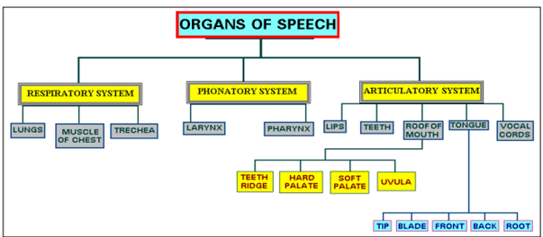

**1) The Respiratory System**:- The organs of speech of which the Respiratory system is comprised are the lungs, the muscles of the chest and the windpipe or trachea. The primary function of the lungs as we all know, is to enables to breathe or respire.

The function of the Respiratory system is to provide the air stream which is the basis for the production of speech sounds. It is the air stream that acts as a source of energy and is modified by the speech organs as it passes in and out of the lungs during the normal course of breathing.

**2. The Phonatory System:**- The Phonatory system is comprised of the larynx in the throat. As we have already said the air that comes out of the lungs is modified before it meets the outside air. At first, the air is modified in the upper part of the trachea where the larynx is situated. The larynx is a muscular structure.

* **The vocal cords can be held wide apart** with a wide opening between them (the glottis). The air can pass freely through this opening without setting the vocal cords into vibration. This is the position of the vocal cords when we breathe. A large number of speech sounds are produced with the vocal cords in this position. Some of these are called voiceless sounds. For example, the first, sounds in the English words, sit, sheet, lever and think.

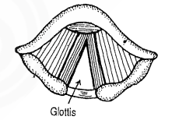

* **The vocal cords can be held loosely together.** When they are in this position the pressure of air from the lungs makes them vibrate. The sounds produced when the vocal cords vibrate are called voiced sounds. For example, the consonant sounds underlined in the English words veil, these, zoo, me, nose. Whereas all English vowels are voiced, some English consonants are voiceless and some are voiced.

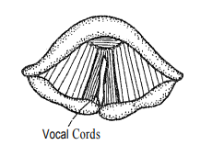

* **The vocal cords can be held tightly together.** The glottis is closed and no air can escape through it. This is the position that the vocal cords take when we eat in to prevent food or liquid from entering the windpipe.

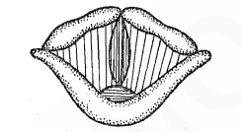

**3) The Articulatory System: -** After passing through, the larynx the air is further modified by the various shapes that the articulators above the larynx assume, because it meets the air outside. Each modification affects the quality of the sound produced.

1. The Pharynx

The pharynx extends from the top of the larynx to the roof of the tongue (the hinder most part of the tongue) which lies opposite it. The muscles of the pharynx can greatly modify the shape and size of the pharyngeal cavity by contracting and expanding. It can also be modified by the movement of the back of the tongue.

1. The Lips

The lips, which are in the front most position of the oral tract, have an important part to play in the production of speech sounds. The consonant sounds 'p/q and /b/a are produced by closing the lips tightly and then releasing the closure abruptly to let out the air built behind the closure.

1. The Teeth

We produce some consonants with the help of the teeth. Similarly, the initial consonant sounds in the English words think, that are produced by placing the tip of the tongue between the upper teeth and lower teeth.

1. The Alveolar Ridge/Teeth Ridge

The alveolar ridge is situated immediately after the upper front teeth. The sounds which are produced touching this convex part are called **alveolar sounds**. Some alveolar sounds in English include: /t/d/.

1. The Hard Palate

Beyond the alveolar ridge is a hard bony surface which we can feel if we move our tongue from the alveolar ridge along the roof of the mouth. Some sounds are produced at the hard palate.

1. The Velum or Soft Palate

The lower part of the roof of the mouth is called soft palate. It could be lowered or raised. When it is lowered, the air stream from the lungs has access to the nasal cavity. When it is raised the passage to the nasal cavity is blocked.

1. The Tongue: The tongue is divided into four parts:
2. The tip: It is the extreme end of the tongue.

b. The blade: It lies opposite to the alveolar ridge.

c. The front: It lies opposite to the hard palate.

d. The back: It lies opposite to the soft palate or velum.

**CHAPTER – 2**

**PLACES OF ARTICULATION**

Consonantial sounds are classified according to three dimensions:

1. Voicing
2. Place of Articulation
3. Manner of Articulation

**Place of Articulation**: The Place of Articulation is the description of the place where the obstruction or constriction in the vocal tract takes place. To describe the place of articulation of a consonant, it must be stated which of the lower articulators articulate with which of the upper articulators.

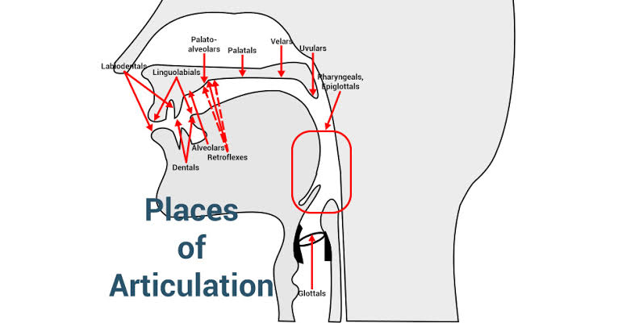

1. **Bilabials**

Bilabials are consonant sounds produced by using both lips together.

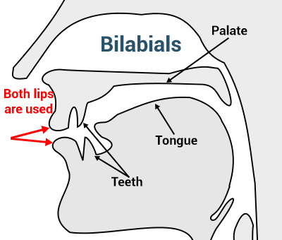

Read this word out loud and notice how you're using both lips to pronounce the letters in bold: ***b****u****mp***.

1. **Labiodentals**

Labiodentals are also pretty straightforward; they are articulated by using both the lower lip and the upper front teeth.

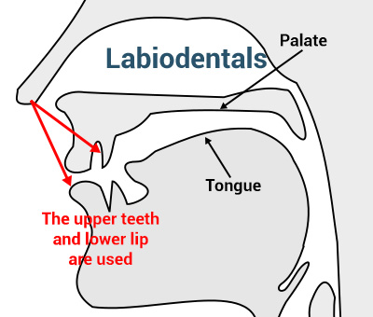

Examples of these sounds in English are pretty much in any word that contains the letters *F* and *V*.

Pronounce the word ***f****a****v****or* and notice the point of articulation.

1. **Linguolabials**

These are articulated by using both the tongue and the upper lip.

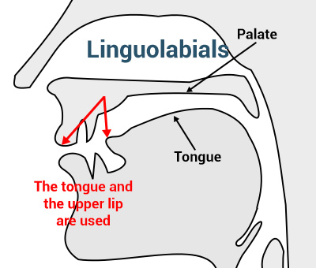

There are very few known linguolabials in languages and there isn’t any language which has any.

1. **Dental**

Some languages have dental consonants where only the tongue and the teeth are used.

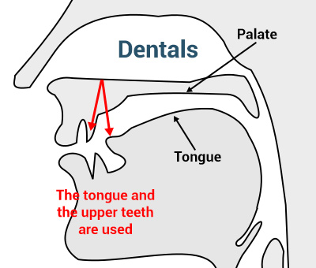

**Examples-**English has two dental sounds: [θ] and [ð].

These consonants are found, respectively, in the words ***th****ing* and ***th****is*.

1. **Alveolar**

The point of articulation of alveolar consonants is situated near the alveolar ridge, which is the area lying between the upper front teeth and the palate.

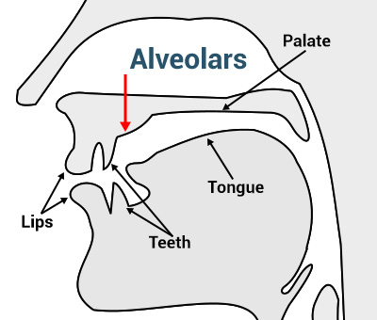

**Example-**Pronounce words such as ***t****ow* and ***z****ap* and you'll feel that the point of contact is at the area shown on the picture.

1. **Palato-Alveolar**

Palato-alveolars occur slightly deeper in the mouth than alveolars:

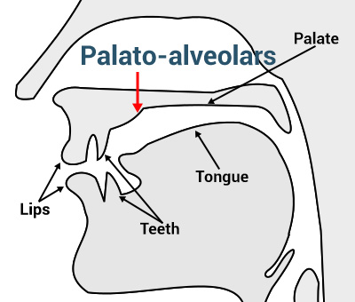

**Examples-**There are at least two such sounds in Standard American English: [ʃ], present in a word like ***sh****eep*, and [ʒ], found in a word like *occa****s****ion*.

To produce the alveolar [s] in the word ***s****ap* and immediately follow it with the palato-alveolar [ʃ] in ***sh****eep*.

1. **Retroflex**

The distinctive feature of some retroflex consonants is that, the tongue curls up slightly on itself when produced.

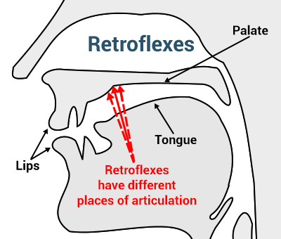

**Example-** Some speakers of Standard American English actually use a retroflex consonant: the [ɻʷ]. It occurs in pretty much any word that starts with *R* followed by a vowel such a ***r****ed* and ***r****eal*.

**CHAPTER – 3**

**SYLLABLE**

A *syllable* is one or more letters representing a unit of spoken language consisting of a single uninterrupted sound. A syllable is made up of either a single vowel sound (as in the pronunciation of *oh*) or a combination of vowel and consonant(s) (as in *no* and *not*).

A word that consists of a single syllable (‘dog’) is called a **monosyllable** .Similar terms include **disyllable** or bisyllable for a word of two syllables; and **polysyllable** (and polysyllabic), which may refer either to a word of more than three syllables or to any word of more than one syllable

**Words with their Syllable Count**

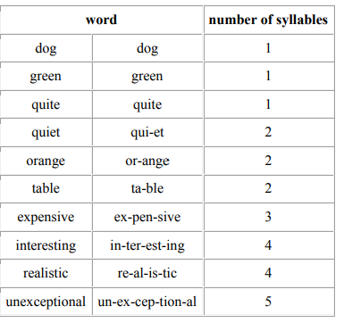

**Summary of Different types of Syllables**

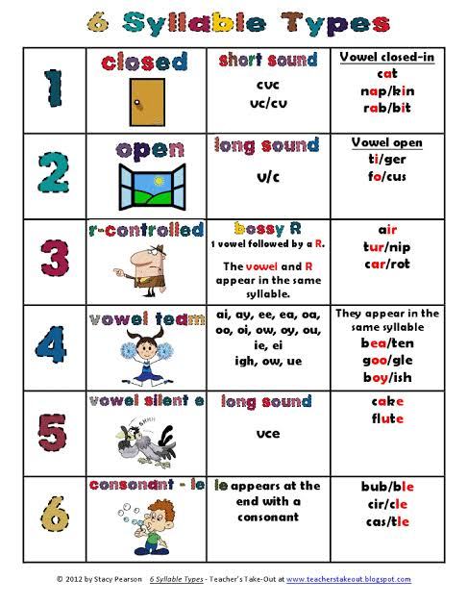

EXAMPLES: -

* teacher:   teach - er
* children:   chil - dren
* pottery:   pot - ter - y
* learning:   learn – ing

**The 44 Sounds in English Language**

* **PHONETICS**: The study of speech sounds and their production. Articulatory phonetics studies the way vocal organs are used to produce speech sounds.
* **PHONOLOGY**: The study of the sound system of a particular language and the general properties displayed by such a system. In contrast with phonetics, phonology only studies those contrasts in sound (the phonemes) which make different of meaning within languages.
* The 44 English sounds can be divided into two major categories – consonants and vowels. A consonant sound is one in which the air flow is cut off, either partially or completely, when the sound is produced. In contrast, a vowel sound is one in which the air flow is unobstructed when the sound is made.

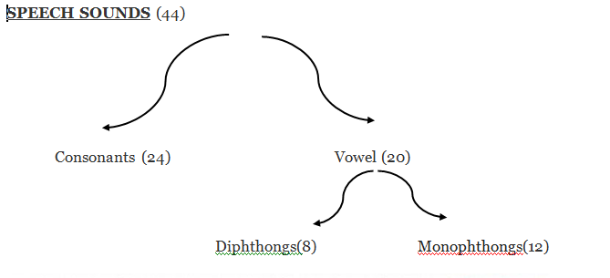

**Consonants**: They are articulated in two ways: partial or total blockage of one of the vocal organs. The closing movement may involve the lips, the tongue, or the throat. From a phonological point of view they occupy the edges or margins of a syllable. They may also appear in clusters or sequences: play [pleɪ]; jump [dʒʌmp]; twelfth [twelfθ].

Thus consonants form an integral part of Phonology and are an essential part of transcription and obviously finds it use in the dictionary as well.

**Vowels:** A sound made without any such restrictions in the airflow. The 20 vowel sounds may be divided into 12 'pure' vowel sounds or *monophthongs* and 8 *diphthongs.* From a phonetic point of view, vowels are articulated with a relatively open configuration of the vocal tract: no part of the mouth is closed and no audible friction is made. From a phonological point of view, vowels occupy the middle of the syllable. Consonants, by contrast, are found at the edges or margins of syllables. BIG [bɪg]; CAP [kæp].

**Examples of vowel and consonant sounds.**

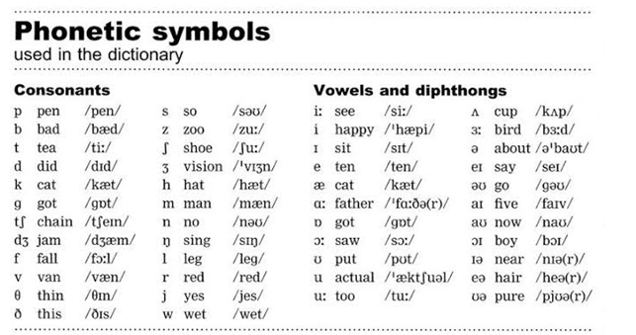

**CHAPTER – 4**

**TRANSCRIPTION**

Phonetic transcription (also known as phonetic script or phonetic notation) is the *visual representation of speech sounds* (or [phones](https://en.wikipedia.org/wiki/Phone_(phonetics))).

* With phonetic transcriptions, dictionaries tell you about the [pronunciation](http://www.antimoon.com/words/pronunciation-n.htm) of words. In English dictionaries, phonetic transcriptions are necessary, because the spelling of an English word does not tell you how you should [pronounce](http://www.antimoon.com/words/pronounce-v.htm) it.
* Phonetic transcriptions are usually written in the International Phonetic Alphabet (IPA), in which each English sound has its own symbol.
* For example, the IPA-based phonetic transcription of the word [HOME](http://www.antimoon.com/sound/home.mp3) is hoʊm, and the transcription of [COME](http://www.antimoon.com/sound/come.mp3) is kʌm. Note that in spelling, these words are similar. They both end in OME.
* Phonetic transcription is usually given in brackets, like this: /hoʊm/, /kʌm/. In a dictionary, it looks like this:

**Common Words with their transcription.**

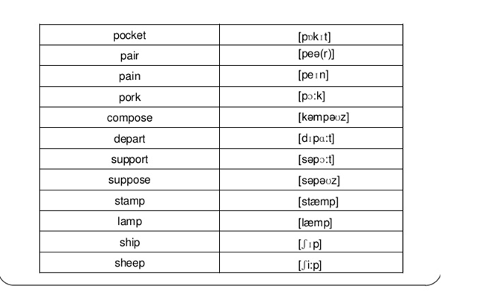

**CHAPTER – 5**

**STRESS**

In [linguistics](https://en.wikipedia.org/wiki/Linguistics), and particularly [phonology](https://en.wikipedia.org/wiki/Phonology), stress or accent is *relative emphasis* or *prominence* given to a certain [syllable](https://en.wikipedia.org/wiki/Syllable) in a word, or to a certain word in a phrase or sentence. That emphasis is typically caused by such properties as increased [loudness](https://en.wikipedia.org/wiki/Loudness) and [vowel length](https://en.wikipedia.org/wiki/Vowel_length), full articulation of the vowel etc.

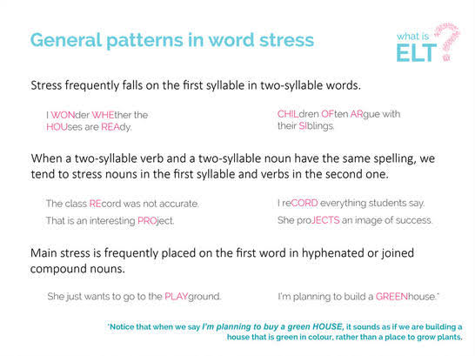

**Word Stress Rules**

There are two very simple rules about word stress:

* + One word has only one stress. (One word cannot have two stresses. If you hear two stresses, you hear two words. Two stresses cannot be one word. It is true that there can be a "secondary" stress in some words. But a secondary stress is much smaller than the main [primary] stress, and is only used in long words.)
  + We can only stress vowels, not consonants.

**A.** Stress on first syllable

**Rule** **Example**

Most 2-syllable nouns PRESent, EXport, CHIna, TAble

Most 2-syllable adjectives PRESent, SLENder, CLEVer, HAPpy

**B.** Stress on last syllable

**Rule** **Example**

Most 2-syllable verbs preSENT, exPORT, deCIDE, begin

**C.** Stress on penultimate syllable (penultimate = second from end)

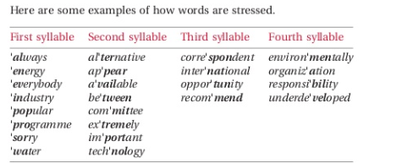

**CHAPTER – 6**

**INTONATION**

In speech, intonation is the *use of changing* (rising and falling) vocal pitch to convey grammatical information or personal attitude. Intonation is particularly important in expressing questions in spoken English. The sentence, "When does the meeting start?" The word "start"—including the question mark—rises up or comes up in your voice when you utter the words.

* Although intonation is primarily a matter of pitch variation, it is important to be aware that functions attributed to intonation such as the expression of attitudes and emotions, or highlighting aspects of grammatical structure, almost always involve concomitant variation in other [prosodic](https://en.wikipedia.org/wiki/Prosody_(linguistics)) features.
* There are two basic patterns of intonation in English: falling intonation and rising intonation.

In the following examples a downward arrow (➘) indicates a fall in intonation and an upward arrow (➚) indicates a rise in intonation.

# Falling Intonation (➘)

(The pitch of the voice falls at the end of the sentence.)  
Falling intonation is the most common intonation pattern in English.  
It is commonly found in statements, commands, wh-questions (information questions),  
confirmatory question tags and exclamations.

Statements

* + Nice to meet ↘you.
  + I’ll be back in a ↘minute.
  + She doesn’t live here ↘anymore.
  + Dad wants to change his ↘car.
  + Here is the weather ↘forecast.
  + Cloudy weather is expected at the end of the ↘week.
  + We should work together more ↘often
* Commands
  + Write your name ↘here.
  + Show me what you’ve ↘written.
  + Leave it on the ↘desk.
  + Take that picture ↘ down.
  + Throw that ↘out.
  + Put your books on the ↘table.
  + Take your hands out of your ↘pockets.
* Exclamations
  + How nice of ↘ you!
  + That's just what I ↘nee

# Rising Intonation (➚)

Rising intonation invites the speaker to continue talking. It is normally used with yes/no questions, and question tags that are real questions.

* Yes/no Questions
  + Do you like your new ➚teacher?
  + Have you finished ➚already?
  + May I borrow your ➚dictionary?
  + Do you have any ➚magazines?
  + Do you sell ➚stamps?
* Questions tags that show uncertainty and require an answer(real questions).
  + We've met already, ➚haven't we?
  + You like fish, ➚don't you?
  + You're a new student ➚aren't you?
  + The view is beautiful, ➚isn't it?